**CS499 – Senior Project: Team Software Design**

**Team Meeting Report**

**(To be turned in by the first class meeting of each week for the previous week.)**

**Project Name:** Theater Ticket Manager (Team 10)

**Week of:** Wednesday, January 13th

**Group Members attending:**

* Jesse Moore
* Matthew Eskridge
* Michael Saki

**Meeting Moderator:**

Jesse Moore

**Meeting Recorder:**

Michael Saki

**Topics Discussed:**

* The project requirements were briefly discussed, and points identified that needed additional clarification. The customer was briefly consulted.
* It was agreed to use PHP with the cakePHP framework as our core technology for completing the project.
* It was agreed that before the next meeting, J. Moore will create an architectural diagram for the project. M. Eskridge will create baseline mockups of the project’s graphical user interface design. M. Saki will translate the customer’s requirements into epics.
* It was agreed that for the initial sprint, J. Moore will serve as Product Owner and M. Eskridge as SCRUMMaster. The roles will cycle every sprint according to the included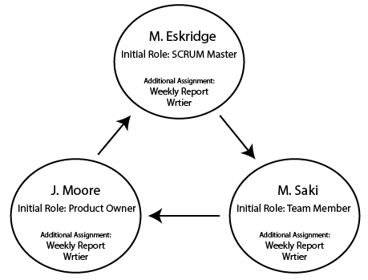 diagram. Next spring, M. Saki will be product owner and J. Moore SCRUM Master.
* Code standards were briefly discussed, and it was agreed that tabs would be used instead of spaces, and braces would be placed on the same lines as block headers.
* All team members agreed to begin learning PHP and cakePHP.

**Problems Encountered* (if any):**

No problems were encountered

**Problem Resolutions**

No problems were encountered

**Scrum Planning**

|  |  |
| --- | --- |
| **User Stories Assigned for this Sprint** | **Assigned To** |
| **Create diagram of software components & data model**  **Create team Trello account for project management**  **Create baseline user interface design mockups**  **Create google drive account for document editing**  **Create list of epics based on customer requirements** | **J. Moore**  **J. Moore**  **M. Eskridge**  **M. Eskridge**  **M. Saki** |

|  |  |  |
| --- | --- | --- |
| **Completed User Stories for this Sprint** | **Completed by** | **Date Completed** |
|  |  |  |